Car Wireless
Music BR- Receiver(hands -free)
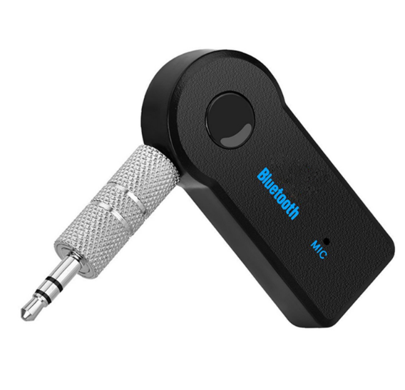
BT-AUX-G

Features
- Suports Wireless Handsfree
- Suports Wireless stereo music play
- Echo cancellation and noise suppression (CVC) technology
- Automatic power-off memory function
- Direct access audio input
- Disconnect, 3 minutes can automatically shut down

Specifications
- Wireless v 3.0+EDR
- Class 2, range 33' (10m)
- Supports A2DP stereo profile
- 3.5mm stereo inlet socket
- Sleep mode for energy saving
- Wireless music BR-Receiver connects to 3. 5mm headphone jacks
- use with home stereos/speakers, car stereos headphones (etc. )
- One touch connect button for easy device pairing
- Up to 8 hours music playback or continuous with mini-USB charger

